Fig. S5

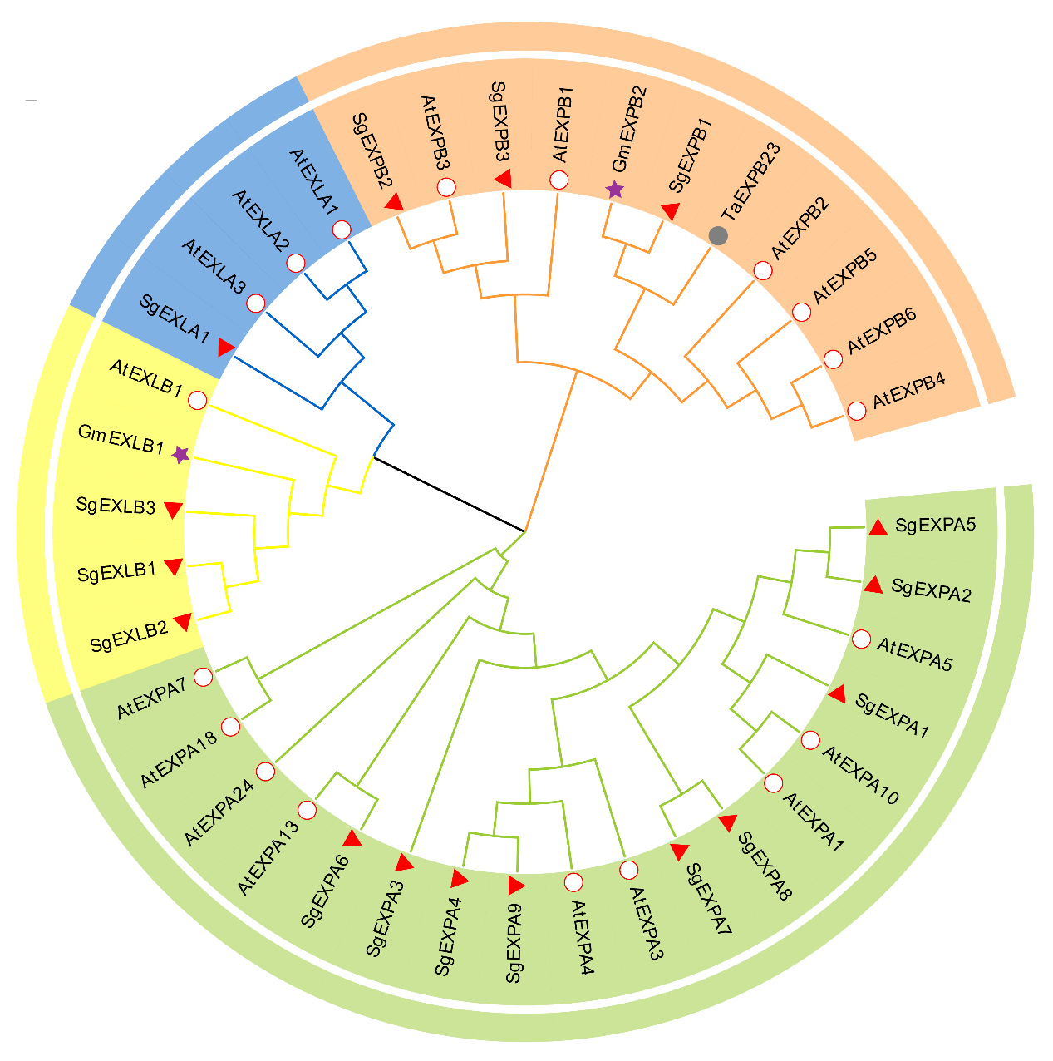
EXPA
EXLA
EXPB
EXLB

Additional file 1: Fig. S5 Phylogenetic analysis of stylo expansin proteins with other expansin proteins in plants. At: Arabidopsis thaliana; Gm: Glycine max; Ta: Triticum aestivum; Sg: Stylosanthes guianensis. EXPA: α-expansin; EXLA: expansin-like A; EXPB: β-expansin; EXLB: expansin-like B.

